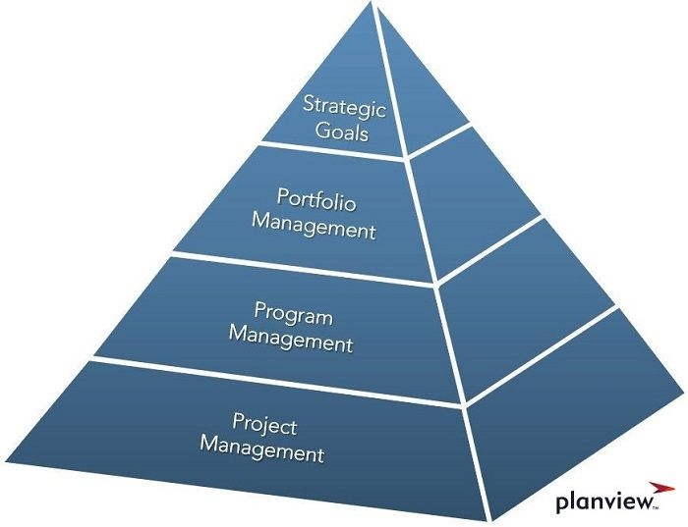

# Management by Projects

The management by projects is a set of activities – like planning, organization, decision making and leadership – which helps leading a company, managing human employees / people and control everything. The intension is to achieve objectives of projects in an efficient and effective manner.

Source: <https://ceopedia.org/index.php/Management_by_projects>

Every project has its own project manager, and the CEO of the company manages all project managers.

### Overview

Management by Projects is a process that aims to successfully plan, execute, and complete individual projects within an organization. It includes resource management, budgeting, scheduling, communication, and risk assessment. It involves creating a clear project plan that defines the project's objectives, milestones, responsibilities, and dependencies.

Another important component is communication. This includes establishing communication channels to ensure that all stakeholders are kept informed of project progress, changes, and issues.

Management by Projects also requires close collaboration and coordination within the project team and with other departments and stakeholders to ensure that the project is completed successfully.

### Consequences

Management by Projects can have a significant impact on the organization of a company. Some of the key consequences include:

1. **Clear roles and responsibilities**: Management by Projects requires clear roles and responsibilities for project team members, which can help to improve communication and coordination within the organization.
2. **Improved alignment with strategic goals**: By managing individual projects to achieve specific goals, organizations can ensure that they are aligning their efforts with their overall strategic objectives.
3. **Increased focus on results**: Management by Projects places a strong emphasis on delivering results and achieving project objectives, which can help to improve overall performance and productivity.
4. **Better risk management**: By identifying and mitigating project risks, organizations can reduce the likelihood of project failure and improve overall project success rates.
5. **Improved communication and collaboration**: Effective communication and collaboration are critical to the success of any project, and management by projects can help to improve both within the organization.
6. **More efficient use of resources**: By managing individual projects, organizations can better allocate and utilize resources, such as personnel and budget, to achieve their goals.
7. **Greater flexibility**: Management by Projects allows organizations to adapt to changing circumstances and respond quickly to new opportunities and challenges.
8. **Better project tracking and visibility**: Management by Projects provides organizations with better visibility into project progress, helping to identify and address issues early on and improve overall performance.
9. **Greater focus on customer needs**: By managing individual projects, organizations can ensure that they are delivering products and services that meet the needs of their customers.

Overall, Management by Projects can help organizations to improve their efficiency, effectiveness, and overall performance.

# Management by Programs

Program Management adds another layer to the company hierarchical structure. This is necessary if too many projects are open in a company and the CEO cannot manage all these projects on his own. The people working in the program management – so called program manager – have the task to organize the projects within their program.

### Overview

Management by Programs is a method of managing multiple related projects as a single program to achieve strategic objectives. It is a more holistic approach to project management, as it focuses on coordinating and aligning the efforts of multiple projects to achieve overall program goals.

One of the key elements of Management by Programs is the development of a program management plan. This plan outlines the program objectives, deliverables, timelines, budgets, and stakeholders, and provides a roadmap for coordinating and managing the individual projects within the program.

Effective communication and collaboration are also critical to the success of any program, and management by programs can help to improve both within the organization. This includes setting up communication channels, such as regular program meetings, to ensure that all stakeholders are informed of progress and any issues that arise.

### Consequences

* CEO has to manage less as long as there are not too many programs and program managers in the company.
* The hierarchical structure gets an additional layer (the program managers).
* CEO can focus a little bit more on strategic goals.

# Portfolio-Management

The portfolio management is used if the company gets really big. The CEO cannot do the management by programs on his own, so he needs another hierarchical layer, the portfolio management. These management group consists of people who guarantee that every program management is inside the portfolio.

The advantage for the CEO is that he doesn’t need to do processes by himself. He can just focus on the strategic goals of the company.

### Consequences

* CEO can really focus on strategic goals
* Another hierarchical structure is added.

# Management by Objective

In contrast to MbProjects and MbProgramms, MbObjective refers to leading a person not a company. As a result, MbO is a transactional leadership. This means that the leadership is based on communication and goals (exchange ratio) between managers and employees.

The aim of this process is to implement the strategic goals of the company as a whole and of the employees by jointly setting goals for each organizational unit and also for the employees. These goals should be SMART:

* S - specific (concrete criteria),
* M - measurable (clear targets),
* A - attainable (achievable, realizable; also: appropriate, attractive, accepted or demanding),
* R - realistic (motivating, comprehensible, realistic, important) and
* T - timed (clear time limit).

Source: <https://media.daa-pm.de/ufv_wirtschaftslexikon/Html/M/PDF/Management-by.pdf>

Source: <https://www.controlling-wiki.com/de/index.php/Management-by-Konzepte>

# MBIT

The company MBIT in Diendorf consists of a small team of around 40 employees. Employees make projects in small groups of 3-4 people.

Therefore, I think that program management (and therefore also project management as well) would be the perfect management model for this company.